**PLATFORM TECHNOLOGIES 101**

**MIDTERM – LAB ACTIVITY 1: Installation - System Access and File System**

**Time Allotted: 1hr 30mns**

**Scoring: 60pts**

**Group Members: Andamon, Joel L.**

**Silverio, John Rey J.**

**“WINDOWS SERVER 2016”**

**Part 1: (40pts.)**

1. Download Windows Server 2016
2. Install Windows Server "Windows 2016 Datacenter (Desktop Experience)"
3. Add additional CPU and 2G of memory to Windows VM.
4. Change Windows VM resolution to fit your screen.
5. Change the hostname and look for system information.
6. Familiarize yourself with Windows Server GUI specially, "Desktop, Start Menu, Task Bar and Search Bar"

**Do provide a screen capture below for numbers 2 to 5 as a proof of performing the task.**

**2.**

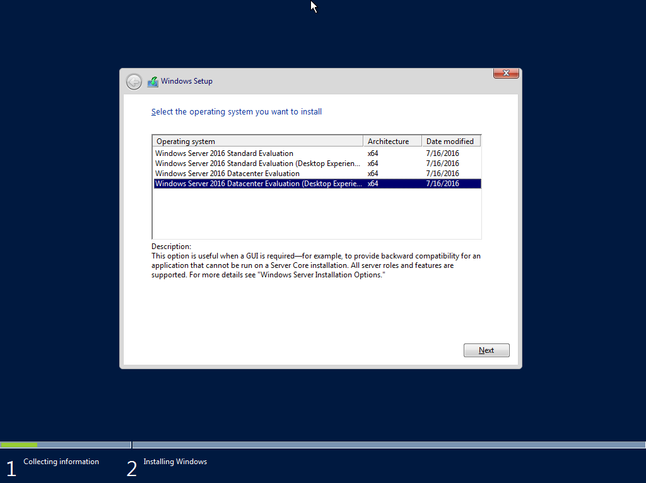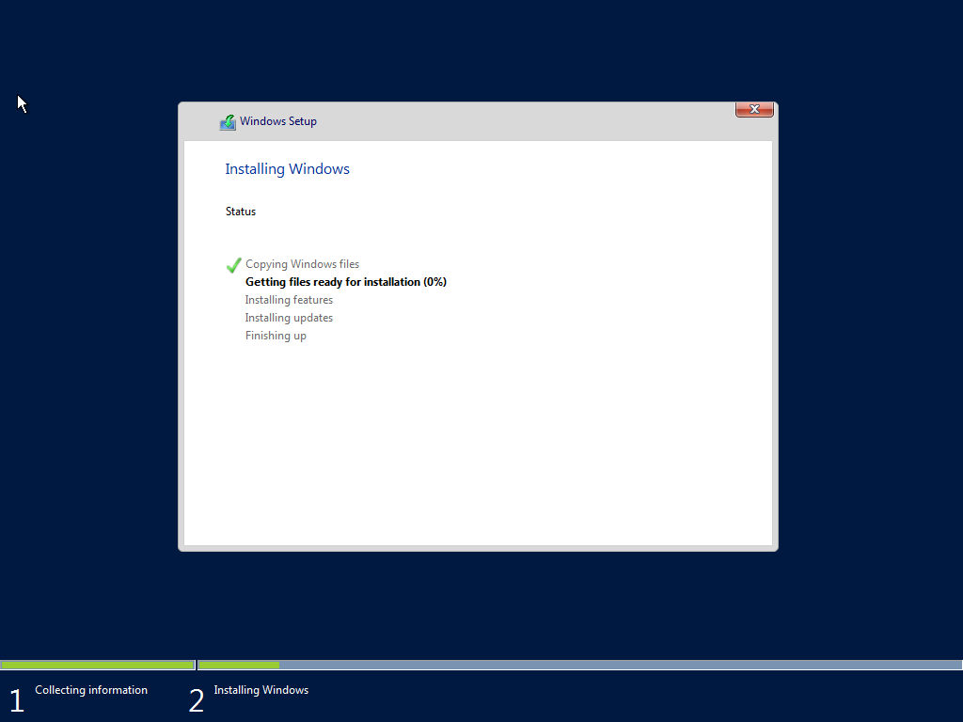

**3.**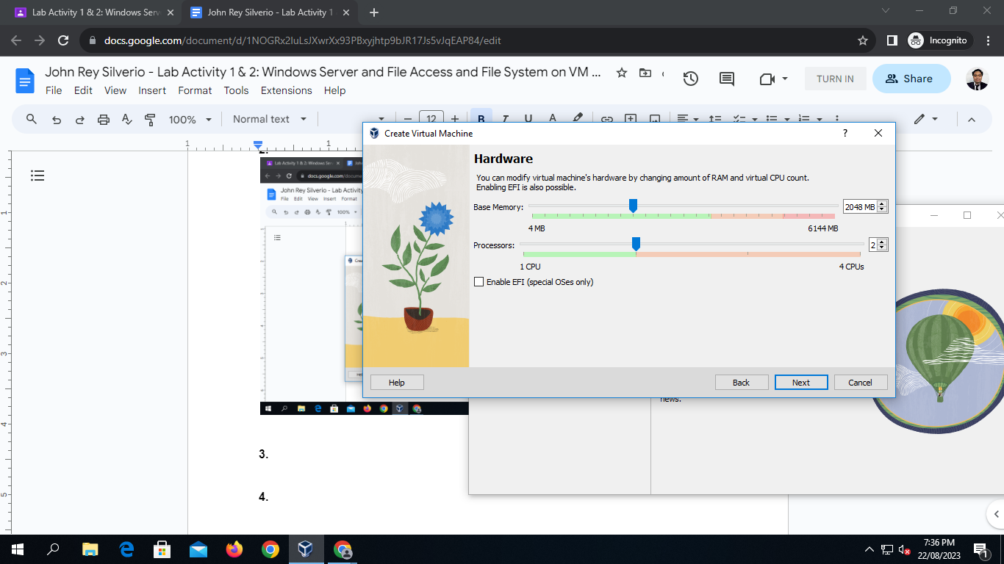

**4.**

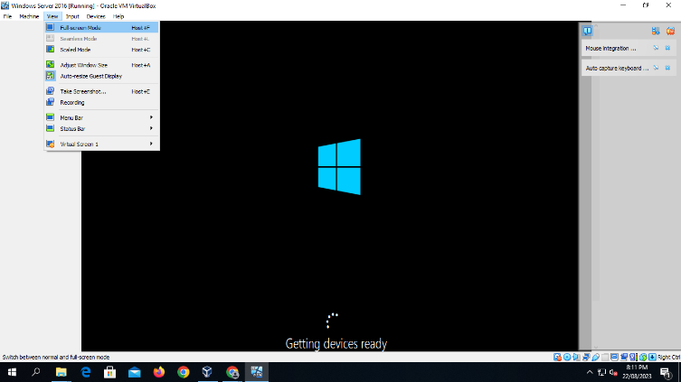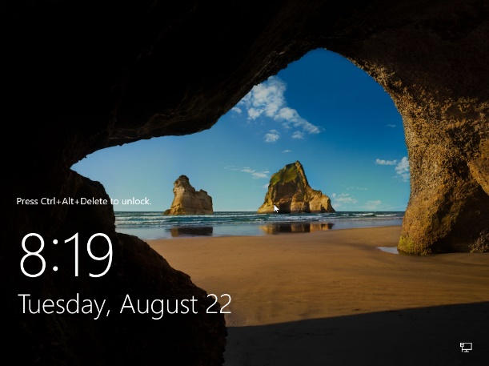

**5.**

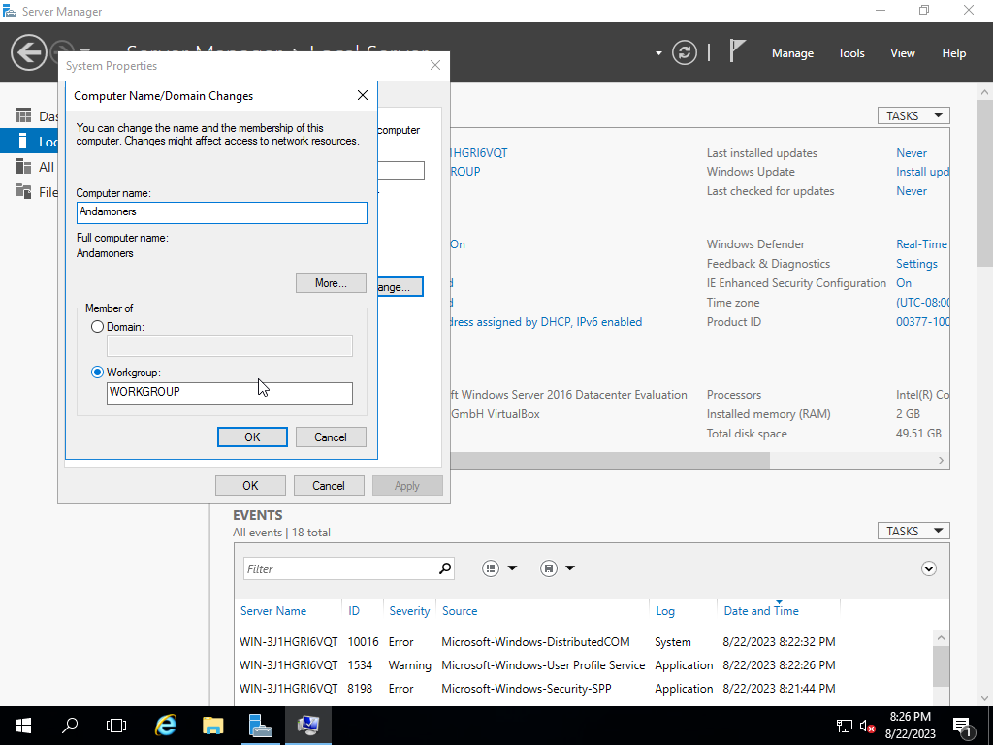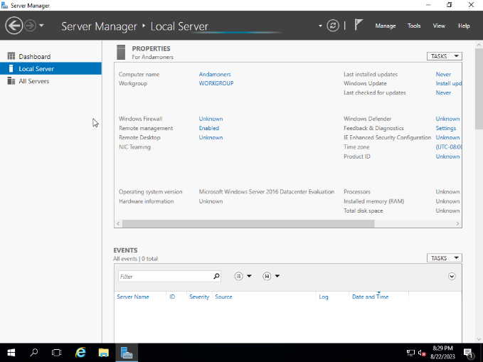

**Part 2: (20pts.)**

1. Continue reading the handout 4 series.
2. Familiarize yourself with Remote Desktop Connection software and the option available in it
3. Practice navigating filesystem (directory, files) using all the methods covered in "Navigating to File System"
4. You should be able to identify each file type in windows otherwise do more research on and find out what are the different types of windows files and files extension
5. Create a directory seinfeld on your desktop.  Then create 4 text files a b c d.  Move a file to desktop using command line.  Rename b to bonus file using command line.  Delete c file using command line
6. Practice file operations keys.

**Do provide a screen capture below for numbers 3 and 5 as a proof of performing the task.**

**3.**

**Browsing through directory**

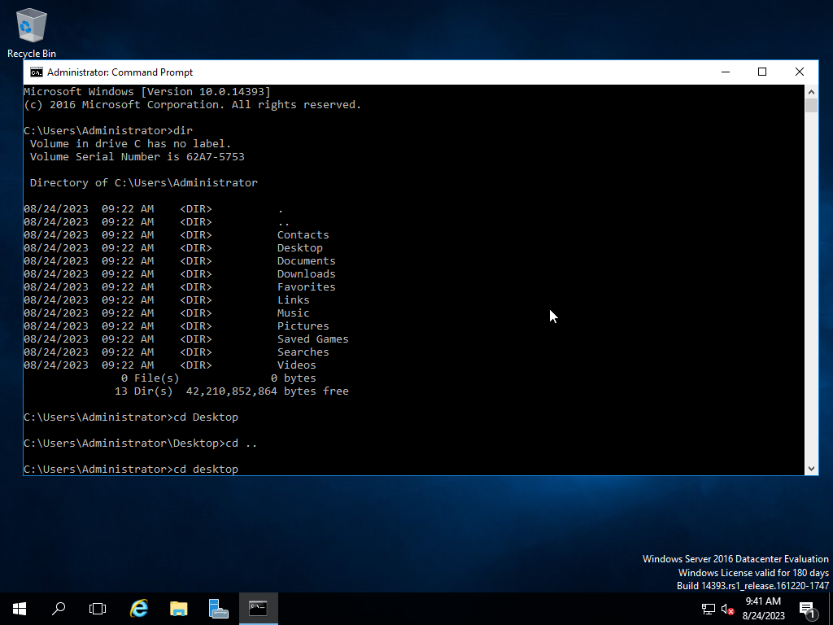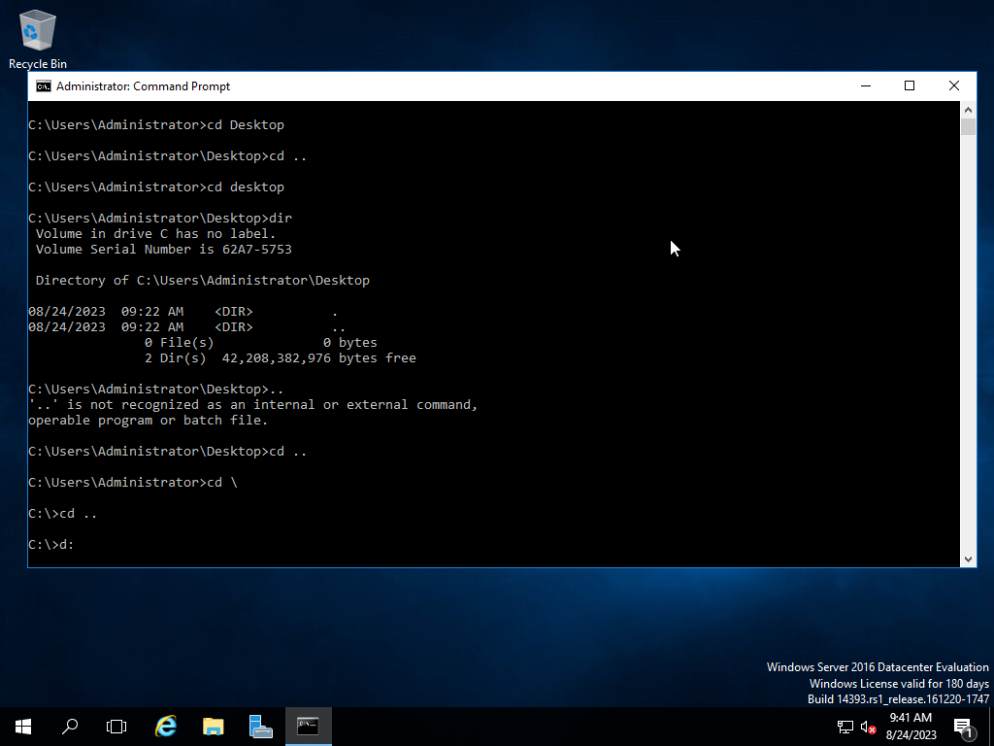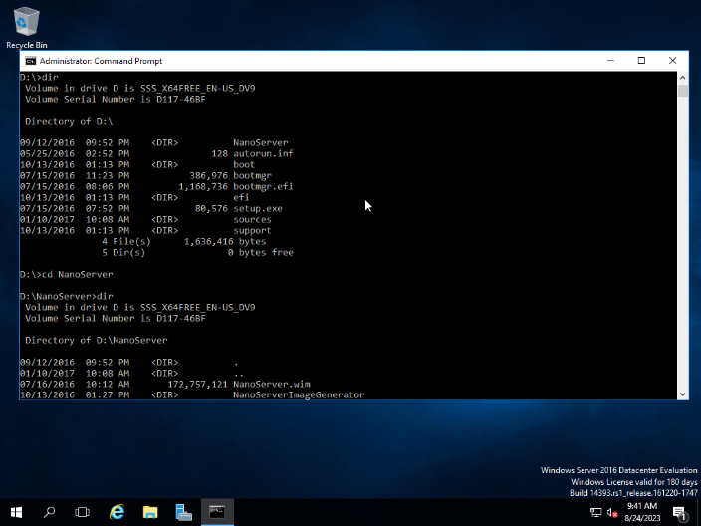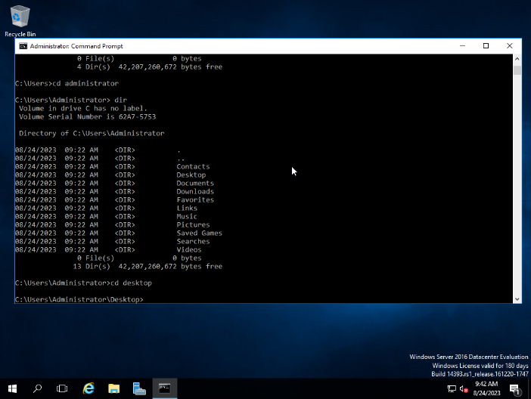

**Opening a txt file named yoshikagekira**

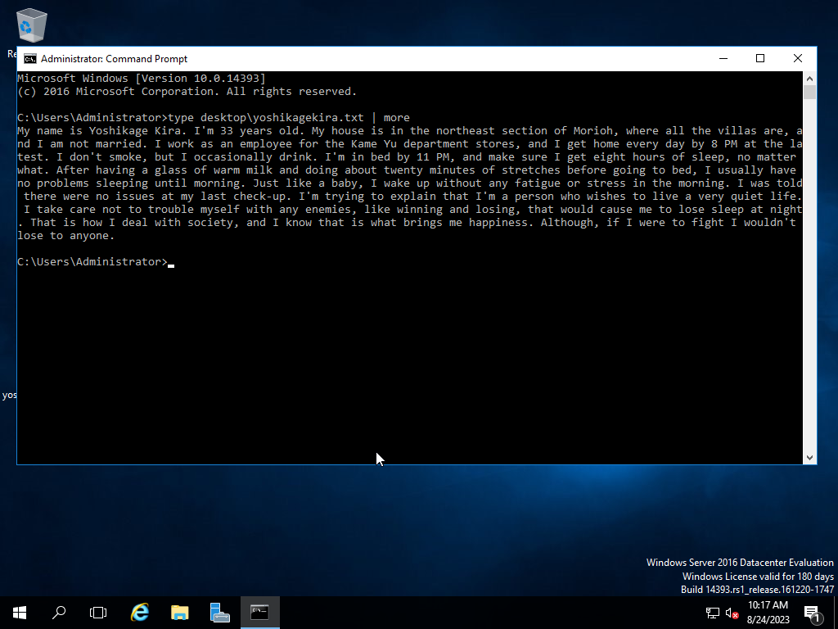

**5.**

**Creating New directory named seinfeld**

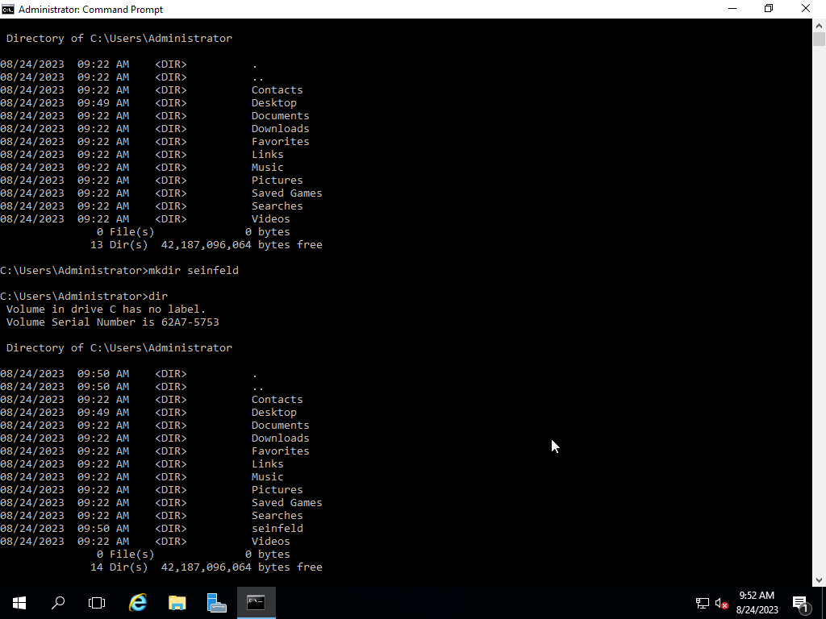

**Adding txt file named a, b, c and d to seinfeld directory**

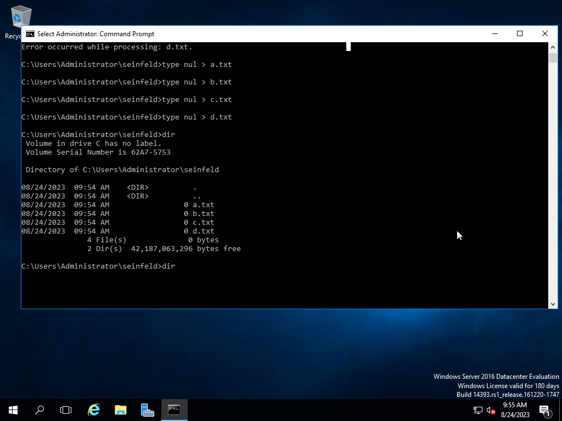

**Moving txt file named a, b, c and d from seinfeld directory to desktop**

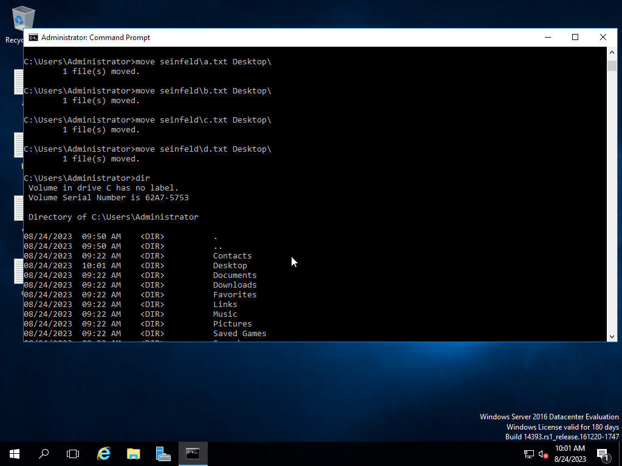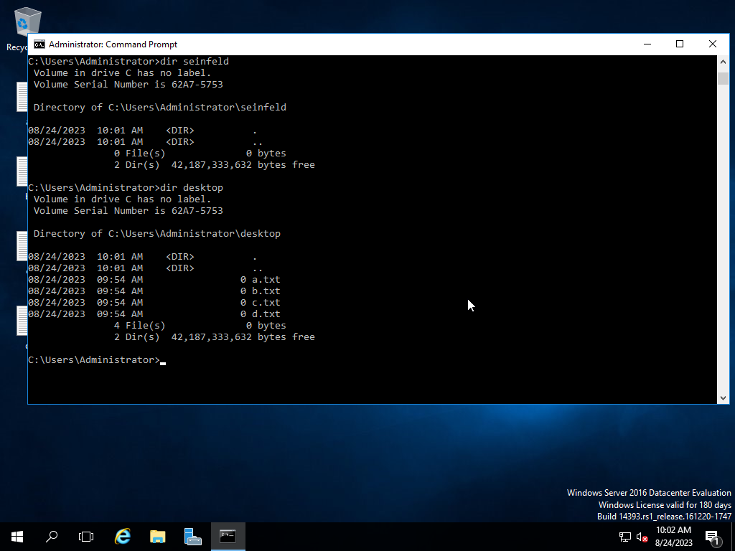

**Changing the txt file name from b to bonus**

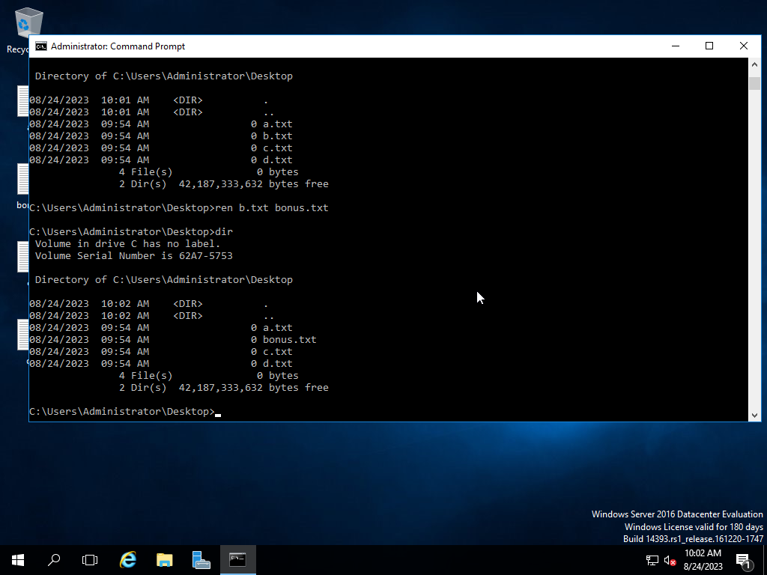

**Deleting a txt file named c from desktop**

